Version 0.0

10.02.2018

The Power House Gym

Gym Invoicing System Design

Krzysztof Stepien

540108

Table of contents

Stage 1: Planning 2

1.1 An anaysis of the project assignment brief 2

1.1.1 Interpretation of the project assignment brief 2

Brief 2

Initial meeting with the client 3

Natural Language Analysis of the brief (NLA) 4

1.1.2 Initial functional and non-functional requirements 6

Website 6

Android Application 6

1.1.3 Initial top level use case model 7

Admins’ use case diagram, descriptions and priority of use cases 7

Personal Trainers use case diagram, descriptions and priority of use cases 9

Users android application use case diagram, descriptions and priority of use cases 11

1.1.4 Information Gathered to clarify Brief - background research 12

1.1.5 Aims of the project assignment 13

1.1.6 Identification of resources and materials 14

Hardware that will be used in the development process 14

Software that will be used in the development process 14

1.1.7 Identification of information sources to be used 15

1.2 Project Plan 15

1.2.1 Schedules for each stage of the project 15

1.2.2 Milestones and deliverables 15

1.2.3 Main tasks 15

1.2.4 Resources 15

References 16

# Stage 1: Planning

## 1.1 An anaysis of the project assignment brief

### 1.1.1 Interpretation of the project assignment brief

#### Brief

„The Power House” gym based in Falkirk always used the classic paper documentation to store all their users data.

Over the years the business was growing constantly, gaining users which caused the documentation to become annoying for the personal trainers and hard to manage over time.

Gym requires a Web-based database system including the website for the personal trainers to use and android application for the users to input data.

Users would use the android app only. At the start users have to register and create the account, inputting the data like email, name and choosing the password.

App would include a list of classes and activities available in the gym, and different forms depending on the class for the users that they use to input their progress and send the data to the server. Users would use the app mainly to track and store their data in order to receive feedback and reports on their progress from the personal trainers. They can also view the simple version of the report in the app.

Classes would include powerlifting, bodybuilding, strongman, with some exercises shared between classes like squat, deadlift, bench press, dips. There are also exercises specific for the classes are:

Powerlifting includes: accessory lifts like weighted pull ups, bent over rows.

Strongman includes: sled pull and push, atlas stone lifts, overhead dumbbell press

Bodybuilding includes: Curls, cable pulldown, calves training, posing and more.

Users would input their lifting results after every class, providing data for the personal trainers.

Users would also store their measurements, weight, body fat % and muscle mass, sending this data once a month which allows them to check their progress over time when receiving the reports from their personal trainers.

Website would allow the personal trainers to log in, view the client accounts and data, assess the progress of the particular client. Trainers would have the option to generate reports and send them and their feedback to the users email.

Reports would include:

* all the data users sent to the database with % increase of the weights lifted monthly
* % of the users measurements, muscle mass, body fat increase or decrease over the month
* Additional notes from the personal trainer.

#### Initial meeting with the client

I am including the initial meeting interview notes just under the brief, because this interview expanded on the functionality and some aspects of the project, which I would like to include in the NLA and design of the Use Case diagrams.

**Notes from the client interview**

* Different ways to achieve the solution:

1. Website with the database access and the android app for the users – Brief option

Pros: personal trainers would have access to the system from any place, users have access to their data at all times

Cons: leaves the most of the data input on the users that cannot be trusted to do it properly.

1. Personal trainers input all the data using the desktop application or the website only.

Pros: total control over the input, no website required, lower costs and development time

Cons: loads of additional work for the personal trainers

1. Different ways to store the data

Locally -requires setting up a file server

External server- less hustle, additional payment

**Clients Decision**

Client decided to include the public website with secure front end, app for the users with validation so the input is controlled and it is not possible for them to input invalid data, data would be stored on the external server.

**Additional Questions**

Q: Customers need the tutorial or an introduction for the app. Would you like to have it programmed into the app?

A: Yes, include the tutorial for the users.

Q: The website should it be local for the company or public, available from any place?

A: Website should be public with the secure front end.

Q: Should there be an admin account that manages personal trainer’s accounts?

A: Yes, include the admin account.

Q: How many personal trainers is hired at the moment.

A: 6.

Conclusion:

* Client decided that the project includes public website with secure front end, app for the users with validation so the input is controlled and it is not possible for them to input invalid data and that the data will be stored on the external server.
* Customers should have the tutorial included in the app (explanation how to use the app)
* There should be an admin account that manages the whole system

#### Natural Language Analysis of the brief (NLA)

Natural language analysis is used to identify the nouns and verbs in the brief in order to find the potential project entities/objects and their behaviours. I have color-coded the brief above, identifying the nouns and verbs.

Here is the list of the highlighted items:

|  |  |
| --- | --- |
| **Nouns – potential entities or objects** | **Verbs – their behaviours** |
| Web based database system | Includes the website for the personal trainers and the Android app for the users |
| Database | Stores the users data |
| Website | Allows the personal trainers to:   * log in * view the client accounts and data * assess the progress of the particular client * generate reports * send data to the users email |
| Android application | Allows the users to:   * register and create the account * input the data like email, name and choose the password * log in * input their progress * send the data to the server * view the simple version of the report * store measurements |
| User | * interacts with the app * receives feedback and reports from personal trainers via email |
| Personal trainer | * interact with the website * assess the users progress |
| Admin | * Have a top level account * Have an option to create, delete, change the personal trainers accounts * Have an option to add, delete, change the data in the database |
| Reports | Include:   * all the data users sent to the database with % increase of the weights lifted monthly * % of the users measurements, muscle mass, body fat increase or decrease over the month * Additional notes from the personal trainer. |
| Classes / activities | Include:   * Powerlifting * Bodybuilding * Strongman * Include exercises- some shaded between classes, some separate for each class |
| Exercises | List of exercises:  squat, deadlift, bench press, dips, weighted pull ups, bent over rows, sled pull and push, atlas stone lifts, overhead dumbbell press, curls, cable pulldown, calves training, posing |

### 1.1.2 Initial functional and non-functional requirements

#### Website

Functional Requirements:

* Allow the Personal Trainer to log in
* View the client account details from the remote database
* View the client data (client input) from the remote database
* Generate reports based on the data stored
* Send the reports to the client via email
* Send feedback and notes to the client via email
* Allow the Admin to log in
* Allow the Admin to view, edit, create, delete the Personal Trainer accounts
* Allow the Admin to view, edit, create, delete data stored in the remote database

Non-functional requirements:

* All the input and changes should be validated before the changes are saved to the database
* In case there are problems with accessing, saving, displaying the data- proper error message should be displayed
* Personal Trainers should log in using their employee number and password
* Log in system should be secure, input should be validated before the data is sent to the database
* Personal Trainer should have possibility to search the client via name, second name or email
* Website should also allow the Personal Trainer to access the users data through drop down list of all users.
* User account details displayed by personal trainers should include name, second name, email, address.
* User data displayed by personal trainers should include users progress data, user measurements, user progress over time
* Generating the report should also offer the option to save it into the text file
* Admin log in should be secure, validated before the input is sent to the database
* Admin should have access to all the features that Personal Trainers have access to
* Website should also allow the Admin to access the Personal Trainer data through drop down list of all Personal Trainers.

#### Android Application

Functional Requirements:

* Allow new users to register
* Allow existing users to log in
* Allow the user to view the classes and exercises
* Allow the user to input their data
* Allow the user to view their progress and their input history
* Store the data in the remote database

Non-functional requirements:

* Display the content on different sizes of the device screen – responsive design
* Validate the register and log in input before the data is sent to the database
* Display the classes and exercises examples and timetables
* Provide the forms and input boxes to handle the data input
* App should be supported on the most popular versions of android operating systems in order to allow access to as many customers as possible

### 1.1.3 Initial top level use case model

This section of the project includes an initial use case diagrams for all the users of the systems. Diagrams clarify the functionality of the system for specific users and describe how the system is expected to behave in the use case descriptions.

#### Admins’ use case diagram, descriptions and priority of use cases

First diagram shows how Admin is interacting with the system (Figure 1), which includes logging in, managing the personal trainer data, managing user data and logging out. Managing personal trainer includes actions like : Display trainers details, create account, delete account, change details. Managing user data includes: displaying user details, adding new users, changing the details of the users or deleting the accounts. Diagram also shows which parts of the system will be validated and which parts of the system interact with the remote database.

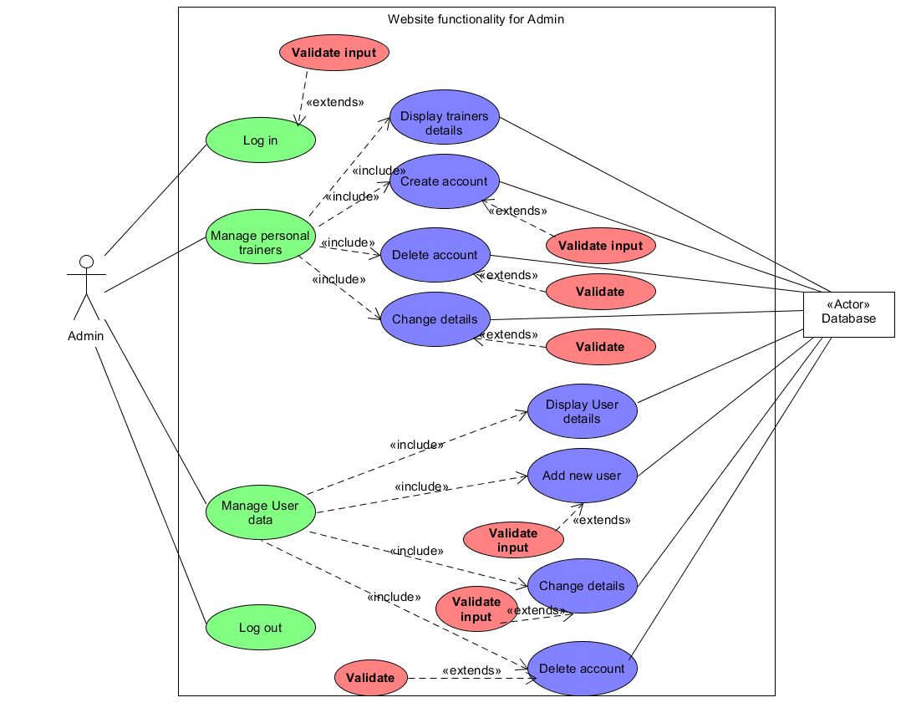

Figure 1: use case diagram for admin

**Admins’ diagram explanation and description of the use cases:**

**Use case 1:** Log in

Admins first action in the system will be to log in using his user ID and password. The diagram also shows that while logging in there is also a possibility of the extension – action performed when the specific conditions apply. In this case it is a validation of the input, If admin will input incorrect data, system will display an error and ask to repeat the input process.

**Use case 2:** Manage personal trainers

After logging in Admin have access to “manage personal trainers” page which includes:

**2a**: Display trainers details: Displays the list of personal trainers present in the system along with their details: email address, name, second name, home address, employee ID.

**2b:** Create account: Allows Admin to create a new personal trainer in the system by adding the necessary data : email address, name, second name, home address, employee ID. Input is validated by the system and error message is displayed when the input is incorrect. If the system accepts the data entry the information is saved in the database.

**2c:** Delete account: allows Admin to choose the personal trainer from the list and delete his/hers account from the database. Before accepting the action system validates if Admin is sure of his decision.

**2d**: Change details: System displays the list of personal trainers, allowing Admin to change and amend their details. Input is validated and error message is displayed if incorrect.

**Use case 3:** Manage User data.

**3a**: Display user details: Displays the details of the customers of the gym, their email address, name, second name, home address, User ID and their input from the android application.

**3b:** Add new user: Allows the Admin to create new account for the customer if needed, input is validated and error message is displayed if incorrect.

**3c:** Change details : Allows the Admin to amend the details of any customer. Input is validated with appropriate error messages.

**3d:** Delete account: Allows Admin to delete the account of specific customer. . Before accepting the action system validates if Admin is sure of his decision.

**Use Case 4:** Logging out

Allows admin to log out from the system, closing the session and preventing the access to other use cases except Log in use case.

**Prioritizing Admin Use Cases**

All of the use cases mentioned above are critical for the systems functionality, however Use case 1: Logging in and 4: Logging out of the system are on top of the priority list. Those two functions are a core of the system and have to be tacked first, including the security and validation connected to them.

Next on the list would be 2a: Display trainers details and 3a: Display user details. Displaying user and trainers details will ensure proper connection between the front end o the system and back end – database and is the “must have” before editing or adding new accounts.

Last priority for this part of the system is adding new accounts, deleting existing ones and editing the data – Use cases: 2b, 2c, 2d and 3b,3c,3d. Their functionality is similar therefore those use cases can be tackled at the same time. The order of managing the tasks:

1. Use case 1: Log in and Use case 4: Log out
2. Use case 2a: Display trainers details and 3a: Display user details
3. Use cases: 2b: Create account, 2c: Delete account, 2d: Change details along with use cases 3b: Add new user, 3c: Change user details and 3d: Delete user account

#### Personal Trainers use case diagram, descriptions and priority of use cases

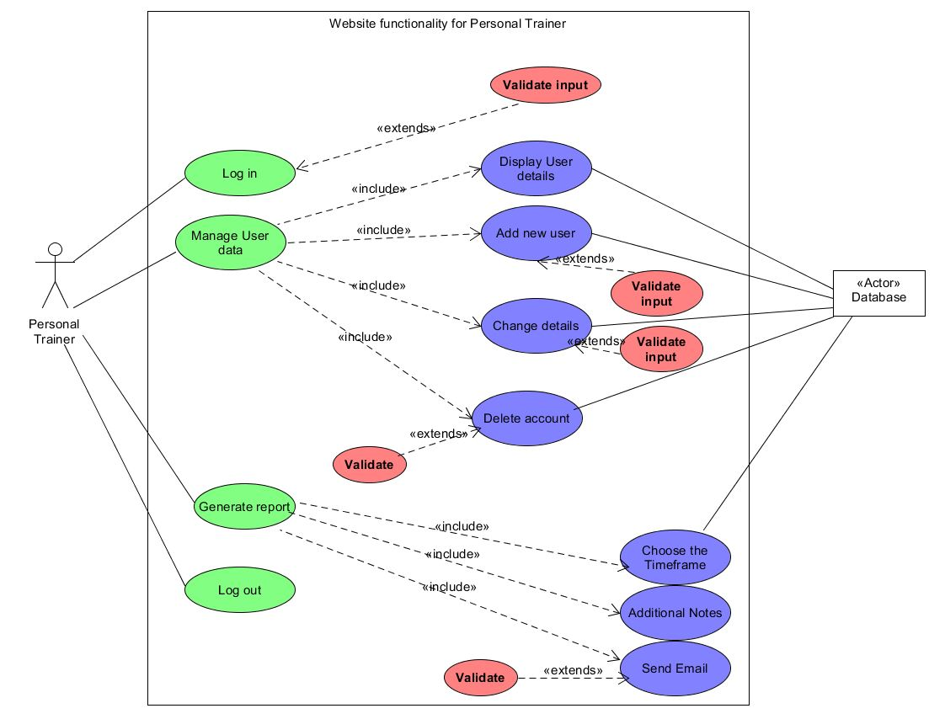

Figure 2: Personal Trainer use case diagram

**Personal Trainer diagram explanation and description of the use cases**

**Use case 1:** Log in and **Use case 4:** Log out

Personal Trainer diagram (Figure 2) explains how the personal trainers will interact with the system and what functionality system offers for them. Logging in and out of the system are the most important functions, Logging in is extended by validation, in order to secure the system.

**Use Case 2** : Manage user data

Managing user data is a second use case, it includes:

**2a**: Displaying the user details,

**2b**: Adding new user,

**2c**: Changing the user details

**2d**: Deleting the users.

All the input involved in those use cases is validated before the data is send to the database. Those use cases allow Personal Trainers to assess the data send in by the users or change, delete data if necessary.

**Use case 3**: Generate report

Generate report use case manages reports being generated and sent to the customers. It includes:

**3a**: Choosing the timeframe for the report: In order to process, analyse the data and generate the report to the customer, personal trainer have to choose the timeframe for the report first. After personal trainer chooses the timeframe, data is pulled from the database.

**3b**: Additional notes use case is also included in the report, personal trainers might want to add the notes that they want to include with the report, their thoughts or conclusion. This use case allows that and attaches the notes with the report.

**3c**: Send Email, personal trainer chooses the customer from the database, system validates if the personal trainer have chosen the right one and sends the email with the generated report and notes.

**Prioritizing Personal Trainer Use Cases**

Just like with Admin case, most important use cases for personal trainers are 1: Log in and **4: Log out**. In order to access other use cases trainers have to Log in with validated credentials. Next on the priority list is **2a: Displaying the user details.** In order for the system to work properly it is crucial to check if the website have proper connection with the database, displaying the information of the users is a first step in this direction. Next is adding the functionality: **2b**: **Adding new user**, **2c**: **Changing the user details** and **2d: Deleting the users**. Last on the priority list is use case **3 : Generating the report** and all the use cases included with it.

1. Use case 1: Log in and Use case 4: Log out
2. Use case 2a: Displaying the user details
3. Use cases 2b: Adding new user, 2c: Change user details and 2d: Delete the users
4. Use case Generating the report

#### Users android application use case diagram, descriptions and priority of use cases

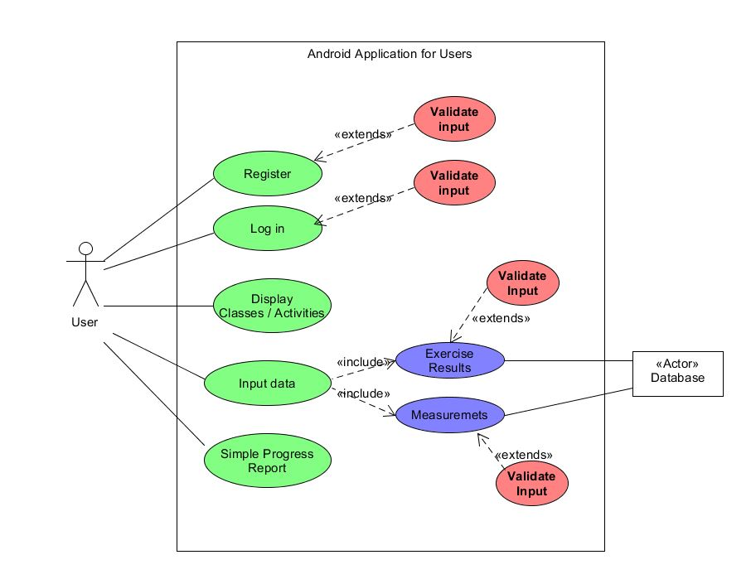

Figure 3 User android Application diagram

**Android application for users diagram explanation and description of the use cases**

Diagram above represents functionality of the Android application the customers of “The Power House” will use to store and assess their progress and track the classes. Initially users will see the Register and Log in use cases.

**Use Case 1 : Register** will be designed for new customers who don’t have an account yet, new customers will be able to input their name, address, email and password, which will end with the app storing the data in the database. Input will be validated and the error messages will be displayed if input is incorrect. Validation will happen before data is sent to the database.

**Use Case 2 : Log in** will allow the customers to enter email/ customer id and password in order to access the rest of the apps’ functionality. Just like the Register use case all input is validated.

**Use case 3: Display Classes / Activities**: This use case displays the timetable of all activities and classes available to the customer.

**Use Case 4: Input Data:** use case designed to hold the functionality connected to customer inputting their classes progress, weight, measurements. This use case includes:

**4a: Exercise results:** Allows the customer to input their results via input boxes or drop down lists. This use case sends data to the database, therefore all the input is validated before this happenes.

**4b: Measurements:** Allows the customer to input their measurements and weight. This use case sends data to the database, therefore all the input is validated before this happens.

**Use case 5 : Simple Progress Report:** This function of the app displays the simple version of the report for the user.

**Prioritizing Android Application Use Cases**

Similar to the previous diagrams **Use Case 1 : Register** and **Use Case 2 : Log in** are the most important functions of the app therefore those tasks will be handled as a priority. Their similar functionality makes them perfect to handle at the same time. Next is **Use Case 4: Input Data** with the sub use cases **4a: Exercise results** and **4b: Measurements** as this is the main functionality of the applications. **Use case 5 : Simple Progress Report** and **Use case 3: Display Classes / Activities** will be handled last because this data might change during the development process. Priority list:

1. Use Case 1 : Register and Use Case 2 : Log in
2. Use Case 4 Input data with 4a: Exercise results and 4b: Measurements
3. Use case 5 : Simple Progress Report
4. Use case 3: Display Classes / Activities

### 1.1.4 Information Gathered to clarify Brief - background research

This section of the documentation discuss the research I conducted in order to initially plan the projects design and how the finished products similar to this project look like. First step was to perform the initial interview with the client (notes can be found in part 1.1.1 of this document, page 3). Main functionality added after the interview was the Administrator account which includes many functions and use cases mentioned in the previous sections of this document.

I have also looked into Android and IOS applications, ones that drew my attention were Jefit (jefit, 2019) and website Myfitnesspal (Myfitnesspal, 2019) offering many fitness related apps. Jefit is an application available both on Android and IOS, it offers a list of exercises and their explanations, along with videos and images. Exercise tracking and logging, reports and stats, also a friend list to share progress with friends- social aspect. It will be useful in this project to test this apps reports, especially how they are formatted and delivered to the customer.

Myfitnesspal offer many similar applications but with greater aim for diet and calorie intake logging and overall fitness. Many of those apps log the data and display reports, or track the progress of their customers. Many of those apps have functionality that can be used as an inspiration for this project functions design.

Website CodeCanyon (CodeCanyon.net, 2019) is a website where developers sell their projects. There are many projects related to fitness / gym , data tracking. This website might be useful to look up the functionality, UI design, reports, data logs used in the projects.

Website medium.org is a place where many people share their thoughts on many different topics. One of the posts made by user Richard (Richard, 2017) described the design process of the PHP based inventory system with use of MySQL. This article is a great explanation on how to pull, amend, display data from the remote database and might be useful in the website design part of this project.

Last bit of research included android documentation for developers (developer.android.com, 2019). This particular page of the documentation referenced explains how to design the application in a responsive way so it will adjust to any screen size and platform version. It will be very useful to keep in mind when designing the application for the users.

### 1.1.5 Aims of the project assignment

All of the aims of this project are included in the initial functional and non-functional requirements of the system. During the design and development time those aims will fluctuate and change but in conclusion the system should :

* Include the website interface for the personal trainers that will allow them to log in, display and change the data of the gym customers. Website will be connected to the remote database, allowing the personal trainers to see what data is stored and produce the reports based on this information. Interface will be secure and all the input will be validated before the data is stored in the database. The website will be a replacement for the traditional paper system of storing information that was used in the past in the gym. Personal trainers will have access to all the gym members data and based on the info stored there will be able to assess the customers progress.
* Website will also include the interface for the Administrator of the system, allowing the access to all the data, including the data of gym members and the personal trainers. Just as personal trainer interface, this part of the website will be secure and all the input will be validated.
* Last aim of this project is to design and develop Android application for the gym members that will allow them to track their classes, input the data to the database and track their progress.

I would also like to mention my personal aims related to this project. Designing the website that allows to manage the data stored on the remote database is a useful skill, a really interesting topic and a great asset to include in my CV in the future. I feel pretty confident designing the front end of the website, but PHP and MySQL part of the project (backend) is a new thing to me. I am excited to design and develop this website and learn new skills, discover libraries managing the databases and techniques involved with developing the backend of projects like this.

Also designing and developing Android app providing the functionality for the users will be a great adventure, will involve a lot of research and will greatly improve my android studio skills. Additionally I have been looking for a simple gym app, that will track my progress and allow me to input data, but with no success. Most of the apps are spamming the user with ads or providing massive amounts of unnecessary functionalities. I just need lightweight app that will allow me to check if I am progressing with my gym or strength and it is really hard to find one. My point is that after developing this app, it will take minor adjusting to make it perfect for my needs and I could actually use it in the future, maybe release it in the app store even.

### 1.1.6 Identification of resources and materials

#### Hardware that will be used in the development process

* My personal PC with Windows 10 with access to the internet and printer
* Forth valley college computers – Windows 7
* Forth valley college remote server – this hardware will provide access to server that will allow to store the data and access it via the website and Android app.
* Android phone with Android 7.0 – will be used to test the gym member application.

#### Software that will be used in the development process

* Windows 10 and 7 operating systems
* Microsoft Word 2019 – tool to create and edit text files. This program will be used to create necessary documentation. This software is available to download for any student from Microsoft Imagine website.
* Microsoft Project 2013 – project management software. This program will be used in developing a plan for the project, timeframe, assigning resources to tasks, analysing the workloads. This program also generates the gantt charts necessary for the documentation. Just like Microsoft word this software is available to download from the Microsoft Imagine website free for the students of FVC.
* Umlet Version 3– windows application that allows to create the diagrams and charts that will be included in the project documentation. Software is available free from <https://www.umlet.com/> website.
* Notepad ++ Portable version 7.1 – software used in web design, allows to create and edit all the web- related files: html, css, php, js. Notepad ++ is free to download from https://notepad-plus-plus.org/
* Oracle SQL Developer Data Modeler version 4.1.5 - software that helps to design the database structure. This product is free, download files can be found on https://www.oracle.com/database/technologies/appdev/datamodeler.html
* Android Studio version 3.3.1 for Windows- this is an official integrated development environment (IDE) that allow to develop applications designed for Android operating system. Android Studio is free to download from <https://developer.android.com/studio/>.
* UwAmp version 3.1.0 is a software consisting of the Apache web server, MySql database and PHP. It allows to set up a server-like environment on the local machine with ease, which will help with testing and running the website part of the project locally from my apartment. UwAmp is free and available from : https://www.uwamp.com/en/.

### 1.1.7 Identification of information sources to be used

## 1.2 Project Plan

### 1.2.1 Schedules for each stage of the project

### 1.2.2 Milestones and deliverables

### 1.2.3 Main tasks

### 1.2.4 Resources

# References

CodeCanyon.net, 2019. [Online]   
Available at: https://codecanyon.net/

developer.android.com, 2019. [Online]   
Available at: https://developer.android.com/guide/practices/screens_support

jefit, 2019. [Online]   
Available at: https://www.jefit.com/

Myfitnesspal, 2019. *myfitnesspal.com.* [Online]   
Available at: https://www.myfitnesspal.com/

Richard, M. m., 2017. [Online]   
Available at: https://medium.freecodecamp.org/making-an-awesome-inventory-management-application-in-php-and-mysql-from-start-to-finish-90bc5996680a